92.11.14
From Johann Eckert
RB MSS M6, Library, Royal Botanic Gardens Melbourne.

Kirchheim via Minyip Nov. 14/92
Sehr geehrter Herr Baron!
Mit abgehender Post sende ich Ihnen die Zeichnung der beiden Isoetes zu. Von den beiden ist die Hume-Isoetes die interessanteste und höherstehende, allerdings auch die schwierigste zum Zeichnen. Ich habe sehr viel Zeit anwenden müssen, um alle Organe aufzufinden, vergleichen und darzustellen. Grosse Schwierigkeiten haben sich im Auffinden der Antheridien gezeigt. Die Anther. dieser und der Wimmera-Art haben keine Cilia, wie der der Fall mit den Kryptogamen ist. Bei der Hume Isoetes sind männliche (megasporangia) und weibliche (microsporangia) Organe auf einem Wurzelstock, männliche aber bei weitem mehr.
Bei der Wimmera-Art habe ich bis jetzt noch keine weibliche Organe (microsporangia) aufgefunden, werde aber, so bald ich etwas Zeit übrig habe, mir frisches Material zum weiteren Nachsuchen herbeischaffen. Obgleich mir die Analyse dieser beiden Pfl. sehr viel Mühe und Zeit gekostet hat, so bin ich sehr froh, dass ich selbige unternommen, denn dadurch bin ich nun imstande auch die blüthenlose Pfl. inbezug auf die Befruchtungs- und Fortpflanzungswerkzeuge genau zu untersuchen; das habe ich zuvor nicht verstanden. Jetzt werden auch bald die Zeichnungen von Geococcus und Cardamine nachfolgen.
War den Druck der Liste von den Glenelg-Pfl. betrifft, so ist es mir vollständig unmöglich dieselbe selbst drucken zu lassen, aus dem Grunde weil ich in Schulden stecke u mich vor weitere Geldausgaben hüten muss. Meine Schulde bis dato belaufen sich auf £60, mein halbjähriges Gehalt, zahlbar den 1. Febr, (nun muss ich bis dahin auch noch Geld gebrauchen) beträgt £42-10, also das fehlende muss ich auf andere Weise herbeischaffen durch Musikunterricht, Extrastunden u.s.w. und so kommt es oft, dass ich über meine Kräfte arbeiten muss, um mich mit meiner Familie ehrlich und respektabel durchzuschlagen. Ich würde ja sonst herzlich gerne die Liste auf eignen Kosten drucken lassen, aber unter den jetzigen Verhältnissen würde ich mich damit in den Bankerott stürzen. Wenn sich aber die Zeiten bessern sollten, so würde ich mit der Veroffentlichung nicht säumen.
Mit herzlichsten Gruss
Ihr J.P. Eckert

Kirchheim via Minyip Nov. 14 /92
Very esteemed Baron!
With the outgoing post I am forwarding to you the drawing of both the Isoetes. Of the two, the Hume Isoetes is the most interesting and the taller, certainly also the most difficult to draw. I had to spend very much time to find all the organs for comparison and illustration. Great difficulties arose in the locating of the antherids. The antherids of this and the Wimmera species have no cilia, as is the case with the Cryptogams. In the Hume Isoetes there are male (megasporangia) and female (microsporangia) organs on the one rootstock, but more male by far.
So far in the Wimmera species, I have not yet found any female organs (microsporangia) but, as soon as I have some spare time, I will get fresh material for further investigation. Although the analysis of both these plants has cost me much time and trouble, I am very pleased that I have done so, as I am now in the position to also closely investigate flowerless plants in relation to their fertilization and reproductive organs, which I have previously not understood. Now the drawings of Geococcus and Cardamine will also soon follow.
Concerning the printing of the list of the Glenelg plants, it is absolutely impossible for me to have it printed myself, for the reason that I am in debt and must guard myself against further expenses. To date my debts amount to £60, my half-yearly salary, payable on 1 February, amounts to £42-10 (until then I must use some money), thus I must get the shortfall another way by music lessons, extra hours and so on and often it happens that I must work too hard, so as to maintain my family honourably and respectably. Otherwise I would certainly be pleased to have the list printed at my own cost, but under the present circumstances I would fall into insolvency thereby. However, if the times should improve, I would not delay the publication.
With heartiest greetings
your J. P. Eckert.

I. Isoëtes from the Hume River Nov. 1892

 | Drawn by J. P. Eckert, Kirchheim
1 | Plant natural size, male and female organs on the same root stock, only male organs much more numerous, about 2 or 3 female organs on each, the rest being male.
2  x  20 | barren leaf, showing the arrangement of cells, clorophyll bodies appearing only at more than one half of the height. The wing-like appendages at the base (which are transparent) small the size are characteristic in this plant, those of that of the Wimmera kind are much larger and different in shape.
3.  x  50 | Portion of leaf with the fovea with a megasporangium or male organ showing also the stomata through which the megaspores escape when mature.
4  x  50 | Same with microsporangium or female organ showing also the dichotomous canal the stomata at the top through which the antherizoids enter when mature.
5.  x  250 | Dichotomous spiral celled canal from microsporangium to stomata
6  x 50 | Microsporangium or female organ
7  x 50 | Different views of megasporangium or male organ.
8 | Transverse section of megasporangium showing the megaspores.
9 | Young megaspore x 250
10 | Mature megaspores, different views, greyish blue in colour, rather hard and brittle x 300
11 | Megasporangium burst open with mother-cells containing the antherizoids x 300
12 | Single mothercell with antheridia, having a parenchymatous double wall. x 500
13.  x 1000  or nearly | Antheridia, bottleshaped, destitute of cilia, but showing a great jerking activity after being liberated from the mother-cell. The motion is vertical, i. e. like that of a ⅔ filled bottle; the head or upper part is rose-coloured and the lower greenish.
14.  x 700 | An empty mother-cell with cilia, which, however only become visible after antherizoids have escaped.
15  about 1000 diameter | Microspores, brown, ciliated, semi-ovate. The contain minute round, transparent corpuscles 16, which I am unable to determine what the possibly can be.

II Isoetes Drummondi (Wimmera species)

1. | Plant Natural size
2 | Lateral view of leaf with megasporangium x 10
3 | Back view of leaf x 10
4 | Megasporang. and stomata through which antherozoids escape x 25
5 | Megasporangium x 25
6 | Megaspore x 300
7 | Mother-Cell containing atherozoids x 400
8 | Mother-Cell broken open and anther. escaping x 500
9 | Antherozoids about x 1000

Cardamine
Geococcus
Isoetes

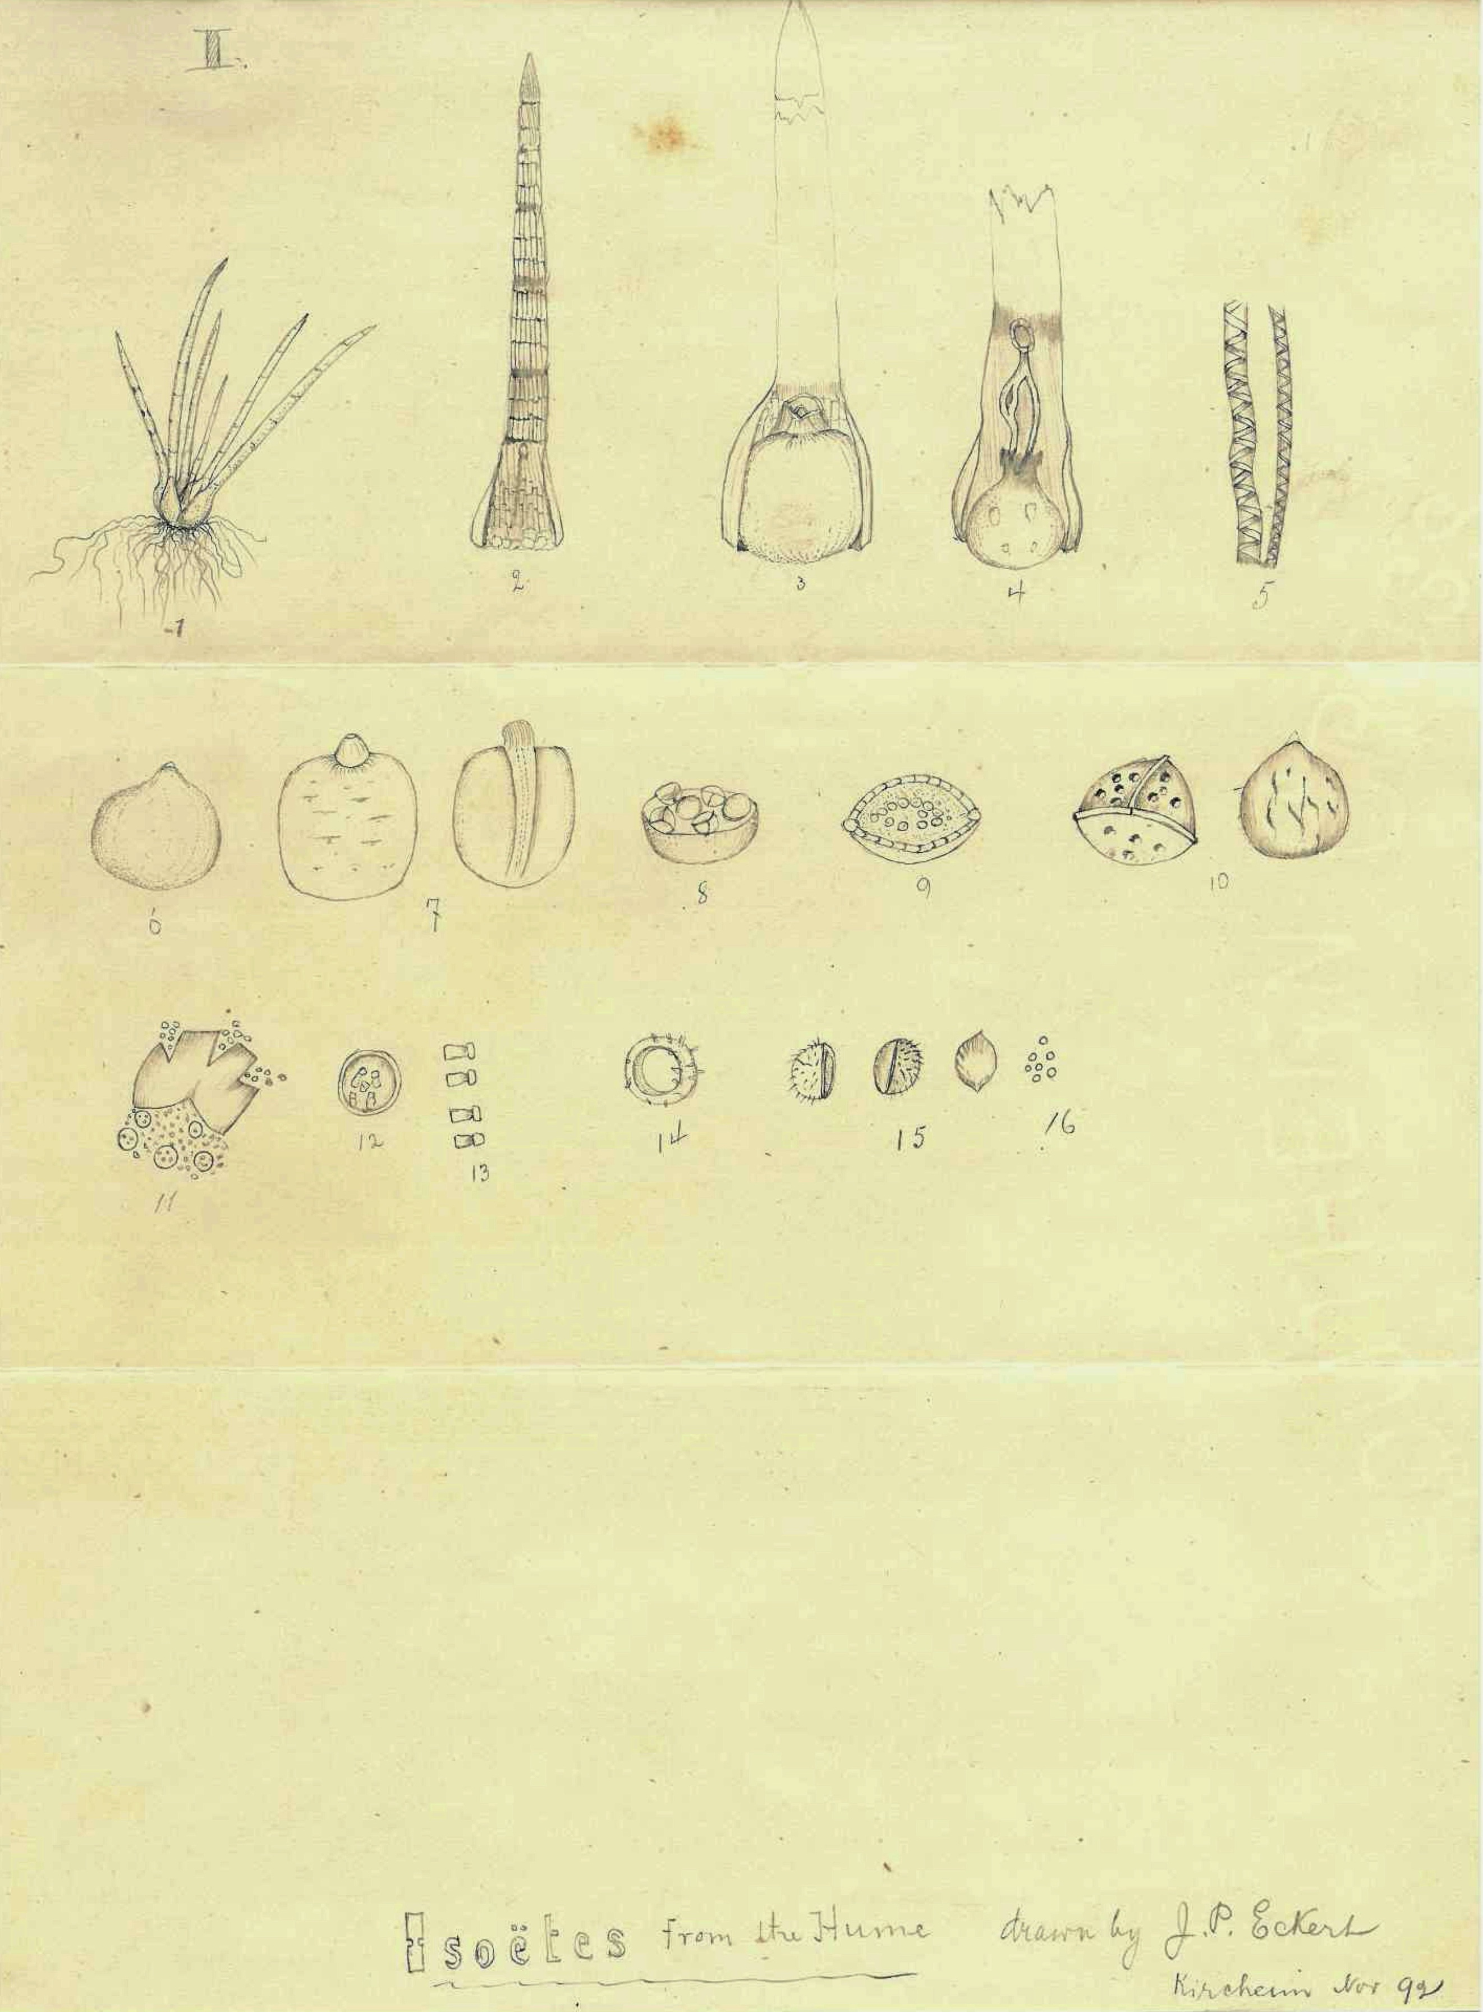

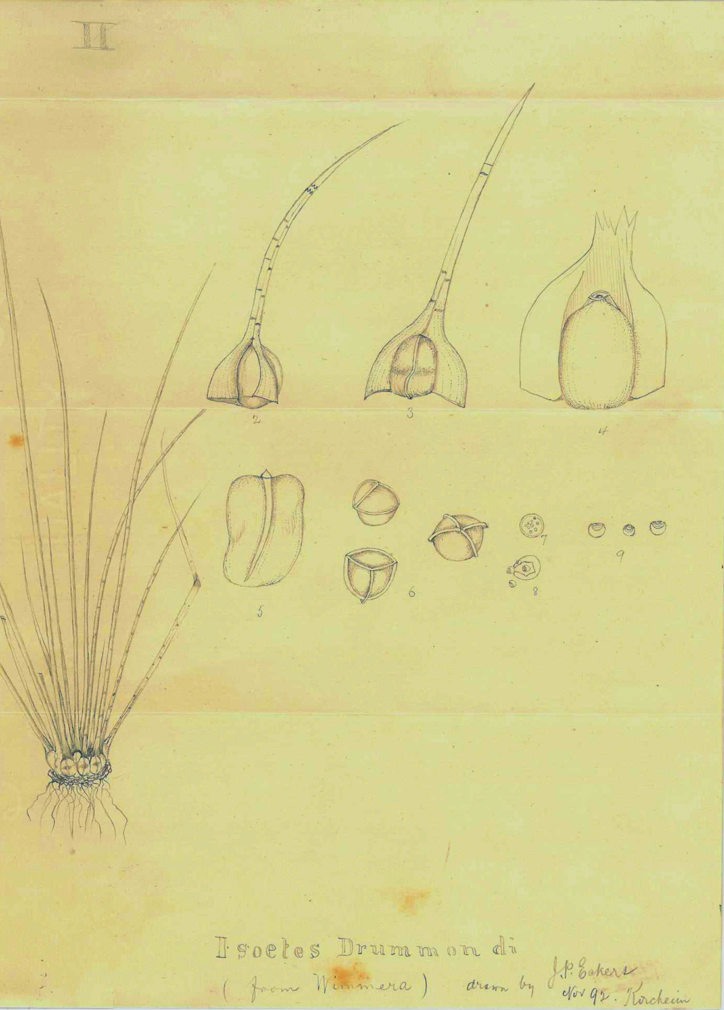

Vic.
Notes explaining the different parts of the pencil drawings accompanying the letter. They are marked: 'I. Isoëtes from the Hume' and 'II Isoetes Drummondi (from Wimmera)'. Each is marked 'drawn by J. P. Eckert' in 'Kircheim' and dated 'Nov 92'. 92-11-14_image01.jpg 92-11-14_image01.jpg The paper on which the images are drawn is 186 mm wide.
20 over 40.
They?
they?
Vic.

